St. Francis Institute of Technology, Mumbai-400 103

**Department of Information Technology**

A.Y. 2023-2024

Class: SE-ITA/B, Semester: IV

Subject: **UNIX LAB**

**Experiment – 6B: Study of various Text Editors.**

**1. Aim:** To study various text editors in UNIX Operating System**.**

2. **Objectives:** After study of this experiment, the student will be able to ● Understand what UNIX operating system is.

● Identify the variants of UNIX operating system. 

3. **Outcomes:** After study of this experiment, the student will be able to ● Understand text editors in UNIX operating system. (L402.4)

4. **Prerequisite:** None.

5. **Requirements:** Personal Computer, Ubuntu 20.04 operating system, LibreOffice, Internet Connection.

**6. Laboratory Exercise**

**A. Procedure**

Prepare a case study for following editor:

vi, nano, pico, emacs, bluefish, brackets,atom, sublime,vim,gedit.

Elaborate on points such as

● modes,

● features,

● commands,

● user interface ,

● installation (if any),

● advantages,

● limitations (if any).

● screenshot of editor screen

**B. Result/Observation**

Attach printout of above case study

**7. Post-Experiments Exercise**

**A. Extended Theory:**

Nil.

**B. Questions:**

1. Compare and contrast vi and vim editor

2. Describe the commands used in vi text editor.

3. Explain the control commands of Nano Text Editor.

**C. Conclusion:**

1. Write what was performed in the experiment.

2. Mention a few applications of what was studied.

3. Write the significance of the topic studied in the experiment.

**D. References:**

1. https://www.cs.colostate.edu/helpdocs/vi.html .

2. https://www.tutorialspoint.com/how-to-use-nano-text-editor

3. Sumitabha Das, UNIX Concepts and Applications, 3rd Ed., Tata McGraw Hill.

ELLABORATION:  **RIYA INDAP,44**

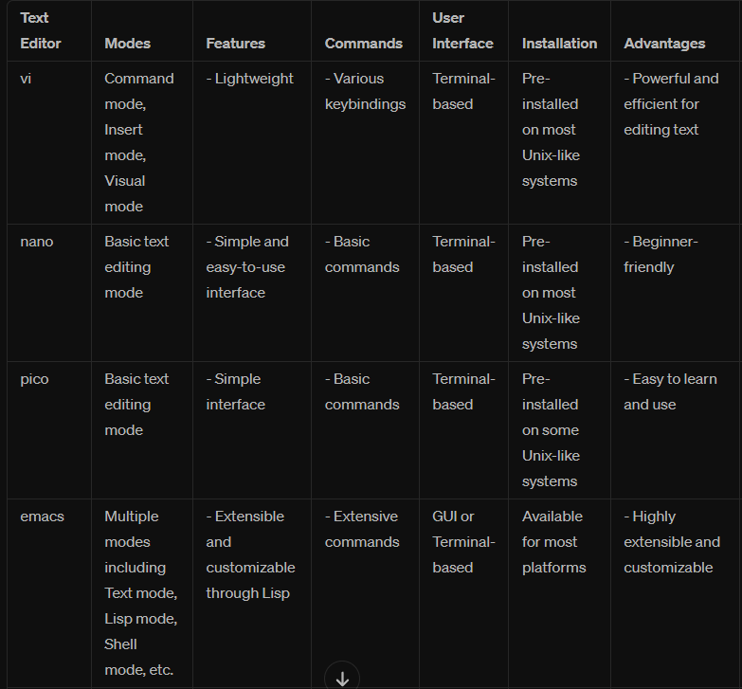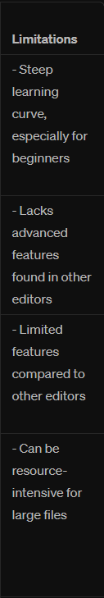

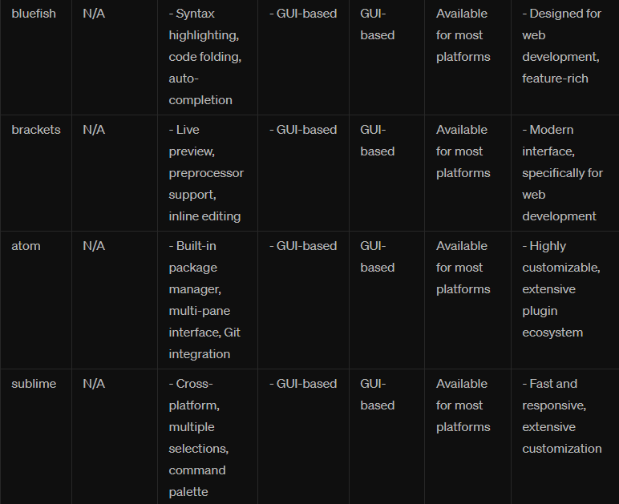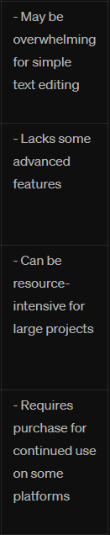

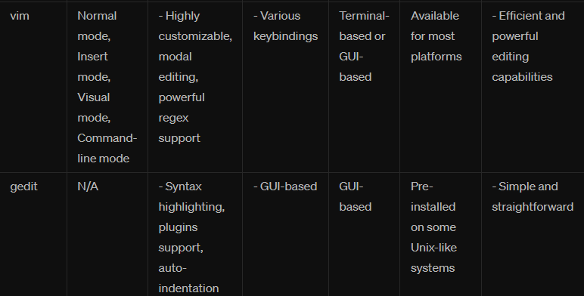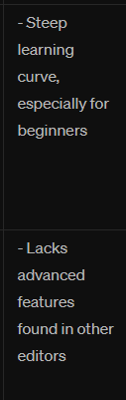

NANO TEXT EDITOR:

